**Group Chatting (Case Study)**

<https://group-chat-spring.herokuapp.com/>

by this url you can test it online

A simple group chat application (Chat room) using

* Spring boot as backend
* HTML,CSS and JS as front end
* File system as data base
* a simple in-memory message broker

There 2 users for testing

VF_1 Password

VF_2 test123

Application Workflow

1. Join group chat with your username and password

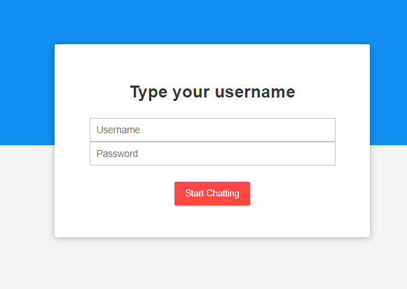

1. Check nullable or empty in JS code then send it to Authentication API in BE.
2. In Authentication API check user credentials in file located in (config/authenticatation.txt) and return with http ok or exception not found

- Use hashed passwords instead of storing plain text passwords. Use SHA-256 for hashing

1. When user join the chat he can send message to all users in the same chat

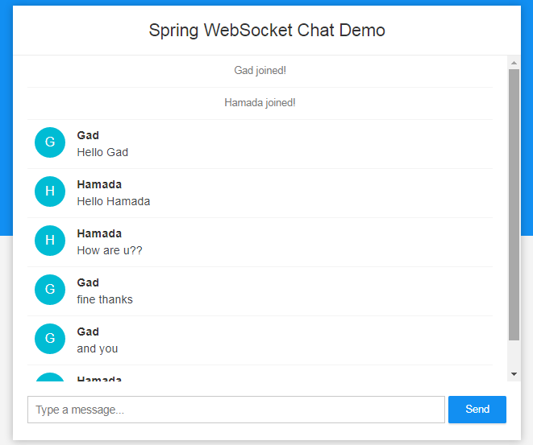

1. When any user “Bye Bye” chat ending automatically and route to blank page
2. By ending the chat

* Dump Conversation into file with username for each user
* Dump Conversation Statistics into (Accumulated Statistics file.txt)